Holy Sepulchre Cemetery Funeral Center
1051 Harder Road, Hayward
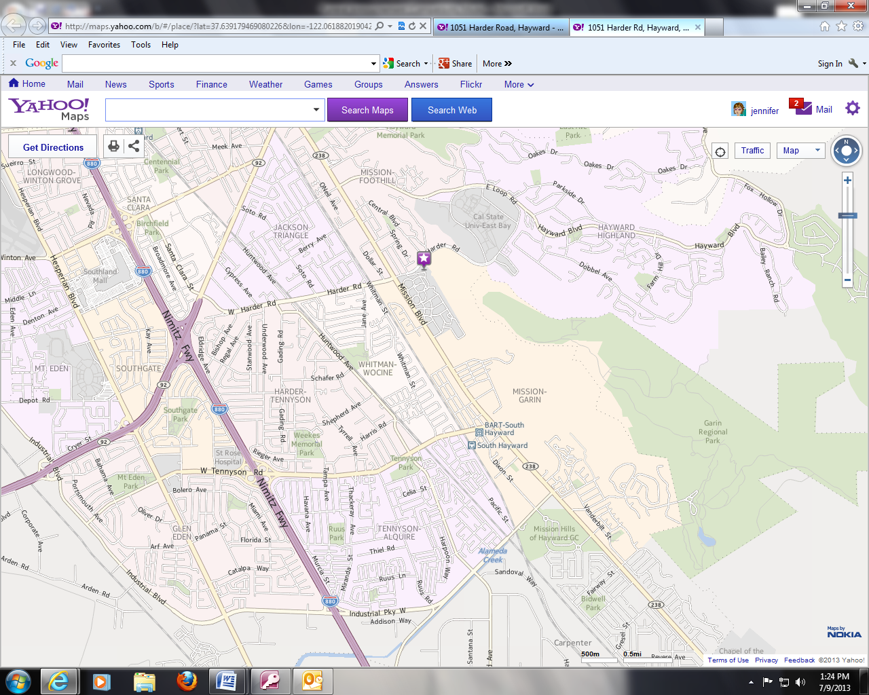
You may enter off of Mission Boulevard and drive through the Cemetery to the Funeral Center or alternate access is directly off of Harder Road
Parking Available next to Funeral Center
Driving Directions from Holy Sepulchre to the home of Eric Hoopes for Remembrance Gathering
4500 Hillsborough Drive, Castro Valley
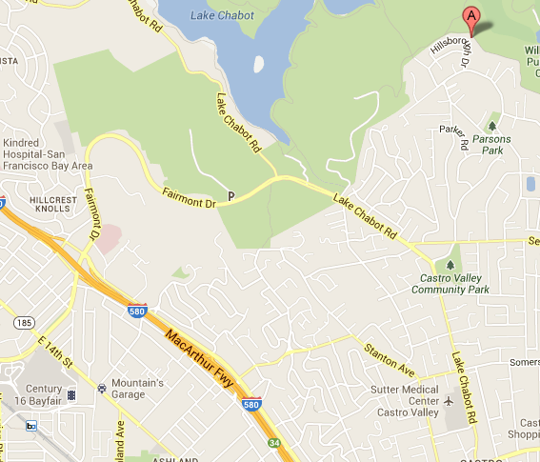
Exit Cementary onto Mission Boulevard
Continue onto Foothill Blvd
Turn right onto East A Street
Continue onto Redwood Road
Turn Left Onto Proctor Road
Turn Right onto Ewing Road
Turn right onto Hillsborough

